**Computer Hardware**

**Class Five**

**Lab 4**

|  |
| --- |
| Lab Objectives:  * Networking Hardware |

# Computer Hardware

## Computer hardware is any physical device used in or with your machine, whereas software is a collection of code installed onto your computer's hard drive.

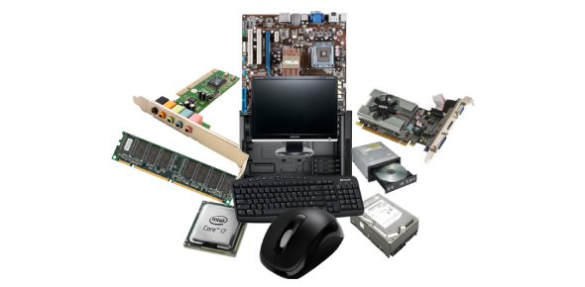

# Networking Hardware

## Networking hardware, also known as network equipment or computer networking devices, are physical devices which are required for communication and interaction between devices on a computer network.

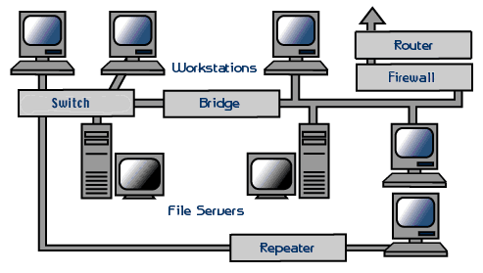

# Most Important Networking Hardware

## Hub

## Switch

## Router

## Modem

## LAN Card

# Hub

## A hub, also called a network hub, is a common connection point for devices in a network. Hubs are devices commonly used to connect segments of a LAN.

## IMG_256

## The hub contains multiple ports. When a packet arrives at one port, it is copied to the other ports so that all segments of the LAN can see all packets.

# Switch

## A network switch is a computer networking device that connects devices on a computer network by using packet switching to receive, process, and forward data to the destination device.

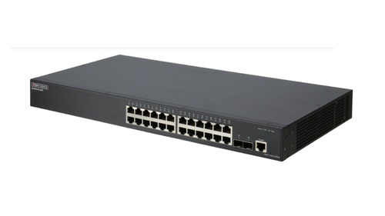

# Router

## A router is a networking device that forwards data packets between computer networks.

# IMG_256

# Modem

## A modem is a device or program that enables a computer to transmit data over, for example, telephone or cable lines.

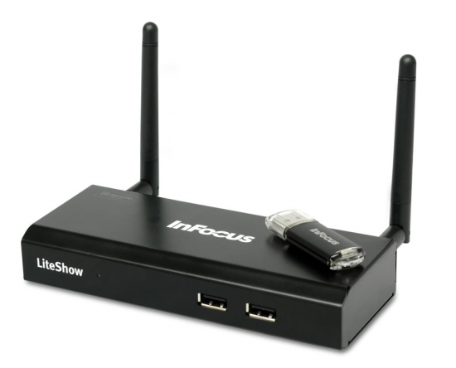

# LAN (Local Area Network) Card

## A LAN card connects a computer to a network.  LAN cards are typically built into your computer.  You can connect to the [network](http://www.certiology.com/tech-terms/network.html" \t "/home/deepto/Documents\\x/_blank) via an [Ethernet](http://www.certiology.com/tech-terms/what-is/ethernet.html" \t "/home/deepto/Documents\\x/_blank) cable, USB, or wirelessly.

# Hub vs Switch vs Router

